**Getting started with GitHub And Vs code**

**STEP 1: Creating new repository in GitHub**

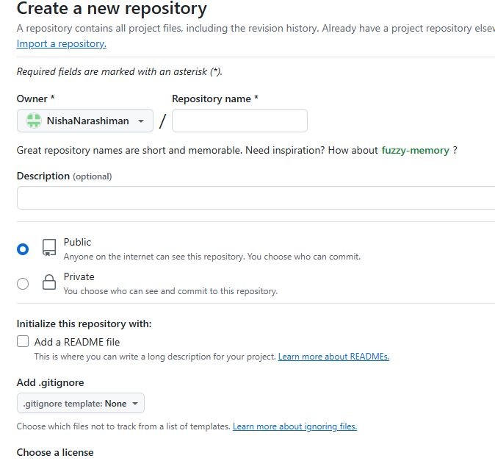

**STEP 2:Naming the repository as Wiproproject for uploading daily assignments**

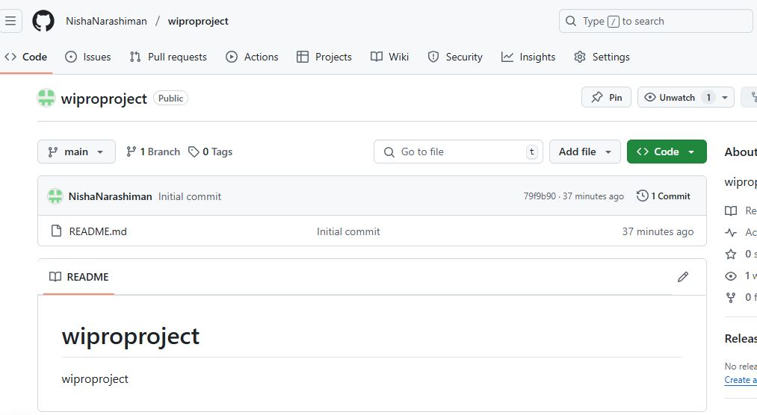

**STEP 3:Creating Folder in Vs code and uploding daily files**

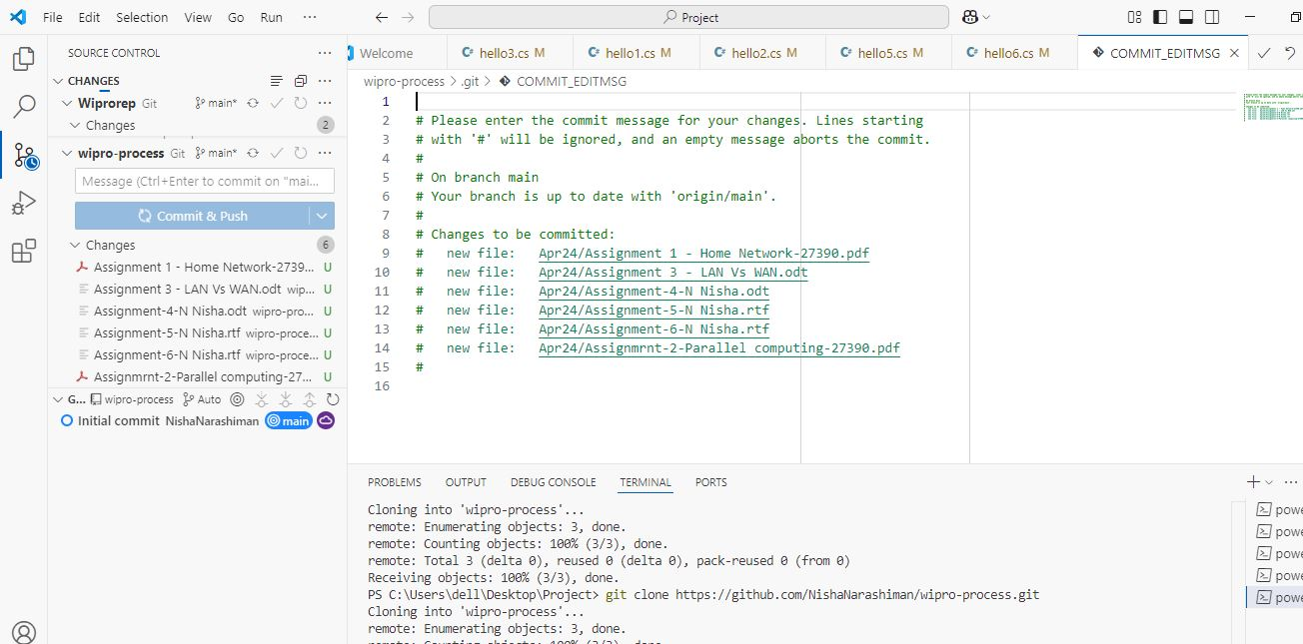

**STEP 4:Files are uploaded in GitHub**

